**Phase 6: User Interface Development**

**Goal :** To design and implement a user-friendly interface in Salesforce using Lightning tools, LWCs, and Apex integration, enabling users to interact with data efficiently and navigate seamlessly through the application.

**1.Lightning App Builder**

* **Purpose:** Drag-and-drop tool to create custom pages without coding.
* **Key Uses:** Build **App Pages**, **Home Pages**, and **Record Pages**.
* **Details:** Place standard components or custom LWCs, save, and activate for users.

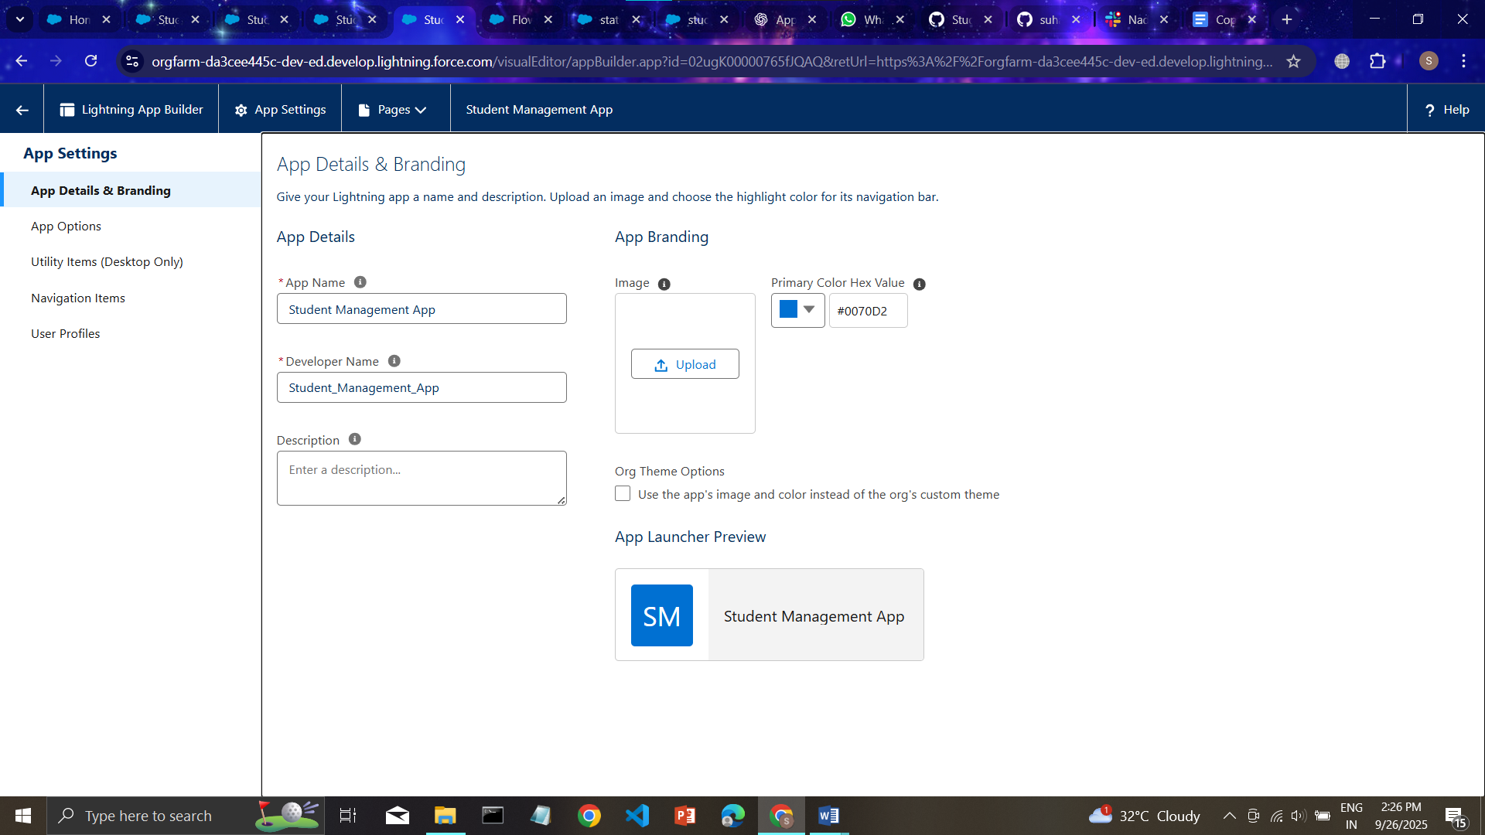

x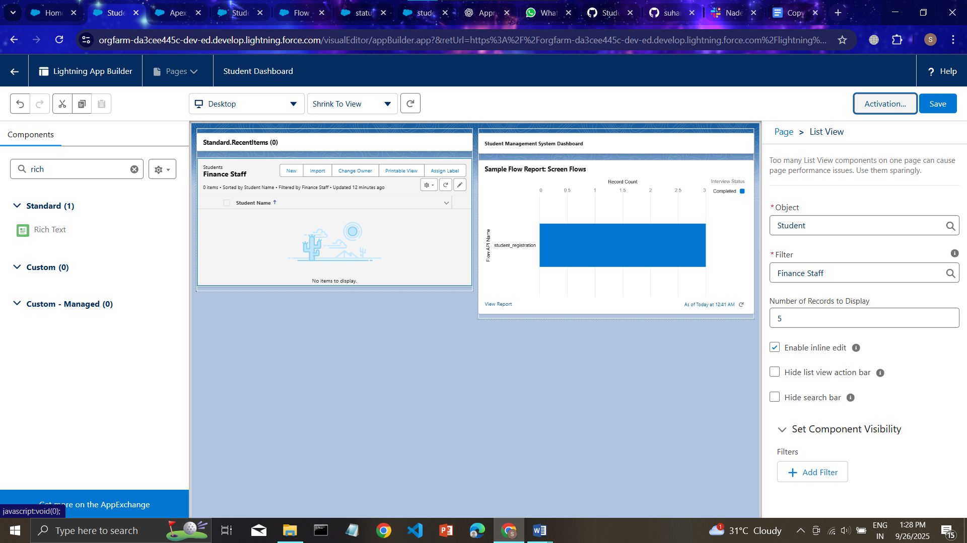

**2.Record Pages**

* **Purpose:** Customize the layout of individual records.
* **Key Uses:** Display key fields, related lists, and custom LWCs for objects like Student or Course.
* **Details:** Assign pages to apps or profiles to control visibility.

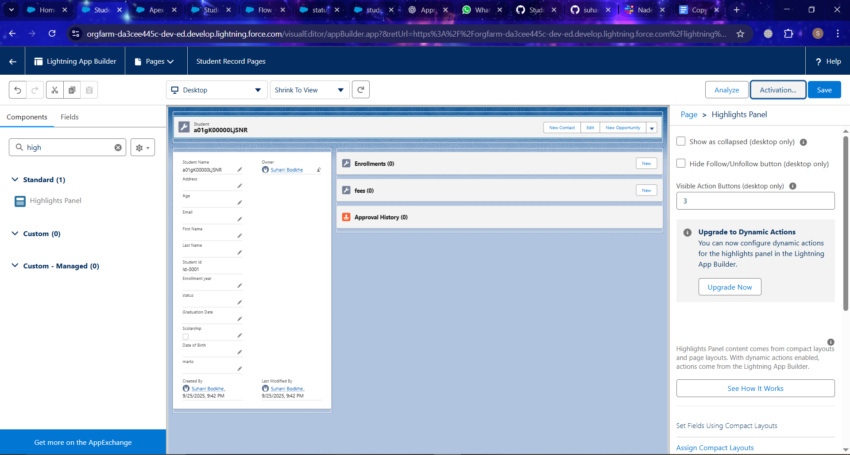

**3.Tabs**

* **Purpose:** Organize objects, pages, or components into tabs for easy navigation.
* **Key Uses:** Access **Students, Courses, Reports**, or custom pages quickly.
* **Details:** Tabs can host objects, Visualforce pages, web pages, or LWCs.

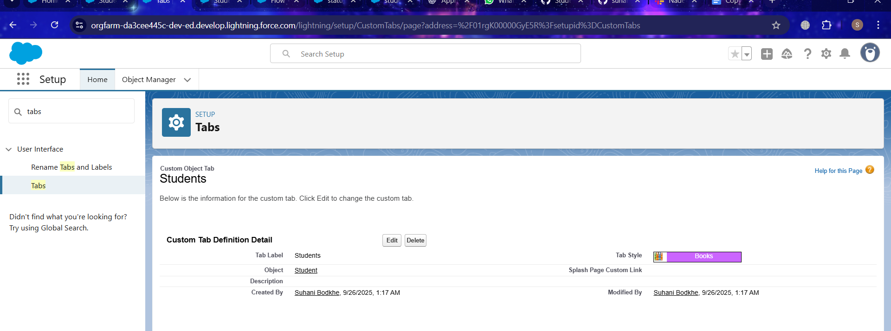

**4. Home Page Layouts**

* **Purpose:** Customize the Home Page for better user experience.
* **Key Uses:** Show dashboards, reports, navigation buttons, and custom LWCs.
* **Details:** Layouts define the structure and visibility of components on the Home Page.

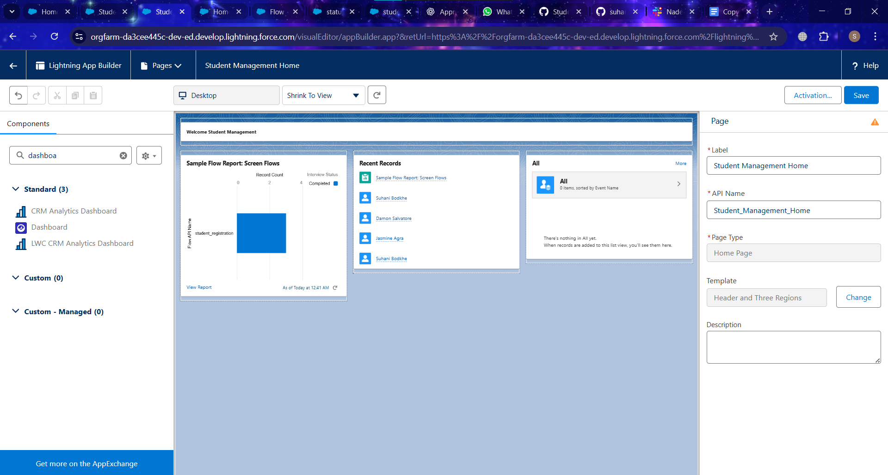

**5. Utility Bar**

* **Purpose:** Quick access to frequently used tools at the bottom of the app.
* **Key Uses:** Add Notes, Messages, or custom LWCs for easy reach.
* **Details:** Can configure behavior, size, and component order.

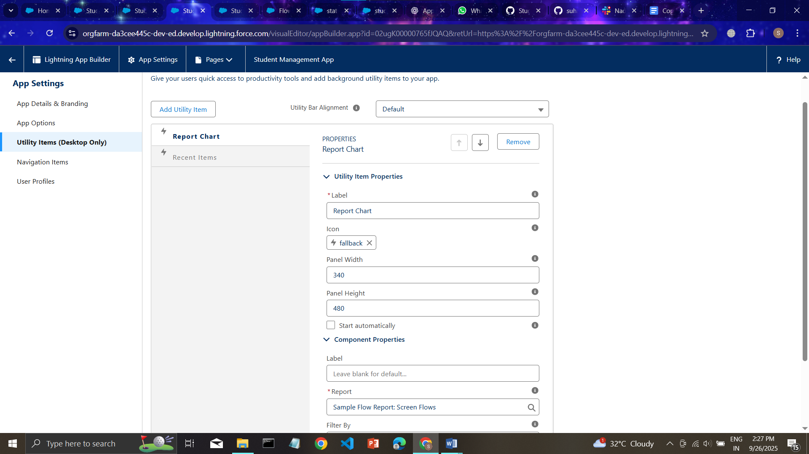

**11. Navigation Service**

* **Purpose:** Programmatically navigate to records, lists, or external URLs.
* **Key Uses:** Navigate users to **Student details, Course list, or external websites**.

